Data Science Professional Practice
Data Science Project and Impact Evaluation
Module M5 | BSc (Hons) Data Scientist

Student Registration Number (SRN): [Insert SRN]
Module: M5 Data Science Professional Practice
Submission: Turnitin
Referencing: Harvard
Total word count: approximately 2,950 (BPP-counted, excluding references only).

Part 1: Data Science Project
Older UK Credit-Card Customers: Usage, Repayment and Later-Life Trends
Public portfolio: [INSERT GITHUB URL]
Executive Summary
This project examines whether older UK adults remain an active credit-card population and whether their card use has changed in recent years. Public FCA Financial Lives data was restructured by age band to compare credit-card holding and actual use in 2022 and 2024, with older repayment evidence from the 2017 survey and ONS life-expectancy data used as supporting context. The strongest pattern is in usage growth: adults aged 75+ increased from 58% using a credit card in 2022 to 67% in 2024, while holding rose from 65% to 74%. Across the published age bands, usage growth was positively associated with age rank, and historic FCA evidence shows strong repayment discipline among older cardholders. The findings do not imply that age predicts individual creditworthiness, but they support reviewing assumptions that older consumers have low demand for credit-card access.
Data Infrastructure & Tools
The main data source was the FCA Financial Lives 2024 survey, a nationally representative survey completed by 17,950 UK adults. The FCA publishes reports, weighted data tables and underlying chart data, which makes the source suitable for a reproducible public portfolio project (Financial Conduct Authority, 2025a; 2025b). The working dataset used the seven standard FCA age bands from 18-24 through to 75+. For each band, the published 2024 percentage holding a credit card and percentage using one in the previous 12 months were captured together with the reported percentage-point change since 2022. Supporting evidence came from the FCA Financial Lives 2017 survey for later-life repayment behaviour and from ONS cohort life tables for longevity. Python was used with pandas for structuring, SciPy for exploratory statistical testing and Matplotlib for visualisation. No internal or identifiable customer data was used.
Data Engineering
The FCA reports presented the required figures across separate credit-and-loans and payments publications, so the first engineering task was to put them into one tidy age-band table. The 2022 values were reconstructed by subtracting each reported 2022-2024 percentage-point change from the corresponding 2024 rate. For example, 75+ credit-card holding was 74% in 2024 and had risen by nine points, giving a comparable 2022 value of 65%; usage was 67% after a nine-point rise, giving 58% in 2022. Age bands were standardised, percentage fields converted to numeric values and an ordered age-rank variable added for analysis. Checks confirmed that every reconstructed value reproduced the FCA change exactly and remained between 0% and 100%. The 2017 repayment figures and ONS life-expectancy figures were deliberately kept in separate supporting tables because their populations and measures differ. This avoided forcing an invalid row-level merge simply to increase the apparent size of the dataset.
Data Visualisation & Dashboards
Three charts were used because the business question is mainly about direction and scale rather than a complex predictive model. Figure 1 compares card holding in 2022 and 2024 across all age bands. Figure 2 isolates the change in actual card use, making the stronger growth in the later-life groups visible. Figure 3 adds ONS cohort life expectancy at age 65 as demographic context. The charts use the same age ordering and percentage scales wherever possible, and captions state the source and limitation so ownership is not confused with borrowing or creditworthiness.
Data Analytics
The main hypothesis was that the increase in credit-card use between 2022 and 2024 would be greater in older age bands. The descriptive results support this. Among adults aged 75+, card holding increased from 65% to 74% and card use from 58% to 67%. The 65-74 group moved from 73% to 78% holding and from 66% to 71% using a card. Across the three 55+ groups, average usage growth was 5.67 percentage points, compared with 0.50 points across ages 18-54. Average holding growth was 5.0 points for 55+ compared with -0.75 points for the younger groups.
An exploratory Spearman rank test was applied to the seven ordered age bands. Age-band rank and the 2022-2024 change in card usage had a strong positive association (rho = 0.873, p = 0.010). The equivalent relationship for card holding was weaker and not statistically significant at the 5% level (rho = 0.595, p = 0.159). This suggests that the clearest recent age-related change is not simply ownership of a card but greater reported use among older groups. The test is deliberately treated as exploratory: it uses seven published aggregate groups rather than respondent-level microdata, so the p-value should not be interpreted as if the seven bands were 17,950 independent observations.
Repayment evidence provides an important second part of the story. In the 2017 Financial Lives survey, 67% of adults aged 65-74 held a credit card and 83% of those cardholders reported paying the full statement balance every month; a further 6% paid in full most months. Among cardholders aged 85+, the FCA reported that only 6% did not pay their statement balance in full every month (Financial Conduct Authority, 2017). These figures are historical and the age bands do not match the 2024 75+ category, so they cannot be presented as a direct trend. They nevertheless show that high age has not automatically meant poor repayment behaviour in FCA survey evidence.
Longevity was treated as context rather than a risk variable. ONS projections estimate a further 22.7 years of cohort life expectancy for a 65-year-old woman in 2024 and 20.0 for a man, rising to 24.6 and 22.0 years by 2049 (Office for National Statistics, 2026). Longer later-life horizons strengthen the case for reviewing age-based product assumptions, but they do not establish affordability or repayment capacity for any individual.
The project also has ethical limitations. Age can become a proxy for assumptions about vulnerability, income or repayment ability. The analysis therefore supports evidence-led review rather than automatic approval. A live credit decision would still require proportionate affordability and creditworthiness assessment and monitoring for poor customer outcomes. The public dataset is aggregated and contains no personal data, which limits privacy risk but also prevents analysis of interactions between age and income, health, vulnerability or other characteristics.
A second FCA measure helps separate card access from sustained borrowing. In 2022, 83% of adults aged 55-64, 79% aged 65-74 and 72% aged 75+ held a consumer-credit regulated agreement; excluding adults whose only relevant products were credit cards, store cards or catalogue credit paid in full every or most months, the figures fell to 43%, 28% and 19% respectively (Financial Conduct Authority, 2022). The reduction is especially large in the two oldest groups. This does not mean older adults never revolve balances, but it supports the view that a substantial share of later-life card holding is compatible with routine repayment rather than persistent borrowing.
The analysis was intentionally kept reproducible rather than made more complex than the public data allowed. A respondent-level model could test whether age remains associated with repayment after controlling for income, housing, health and other factors, but the FCA microdata requires separate access arrangements. Using the published tables avoids pretending that those controls are available. For a future iteration, the same Python workflow could be rerun on respondent-level survey data or linked to a suitably anonymised internal portfolio extract, with age bands compared on utilisation, arrears and loss outcomes while controlling for affordability. That would test the policy question more directly than the aggregated public evidence used here.
Discussion
Taken together, the public evidence provides a coherent but bounded conclusion. Older adults are not a marginal credit-card segment: in 2024 the 65-74 and 75+ groups had among the highest levels of card holding and use, and the largest recent increases were concentrated in the oldest groups. Historic FCA evidence also indicates strong repayment discipline among many older cardholders. At the same time, neither survey activity nor life expectancy proves that an individual older customer is low risk. The useful conclusion for professional practice is narrower: chronological age alone is a weak basis for assuming low credit demand or poor repayment, so later-life credit processes should be tested against actual affordability, behaviour and outcomes. This directly informs the Impact Evaluation in Part 2.
Figures
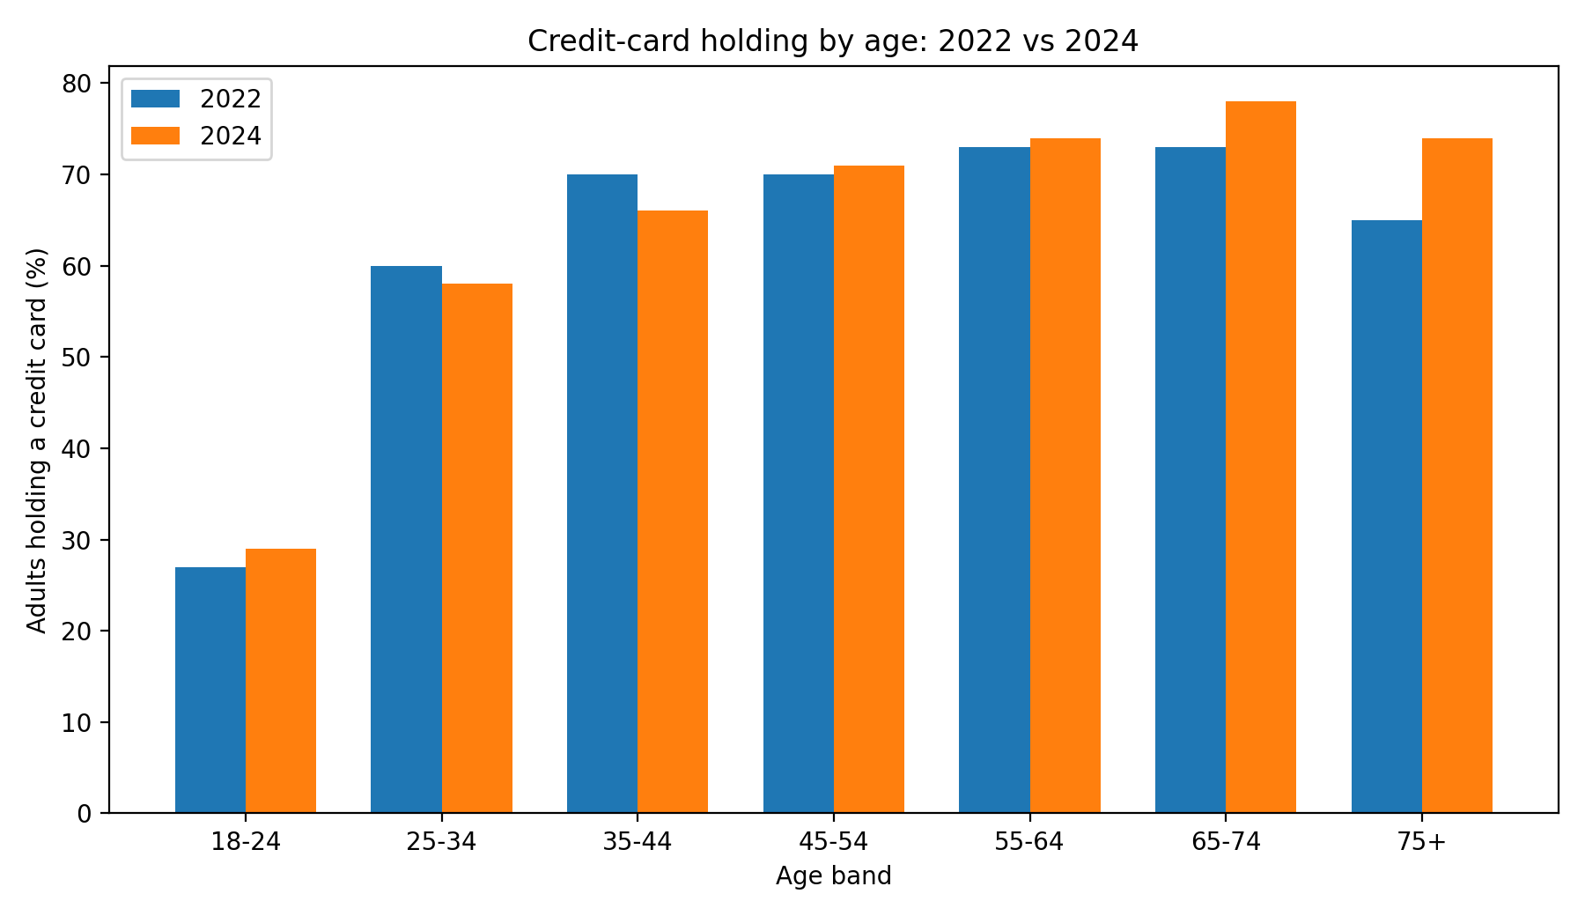
Figure 1. Credit-card holding by age in 2022 and 2024. Source: Financial Conduct Authority (2025a). 2022 values are reconstructed from the FCA-reported percentage-point change.
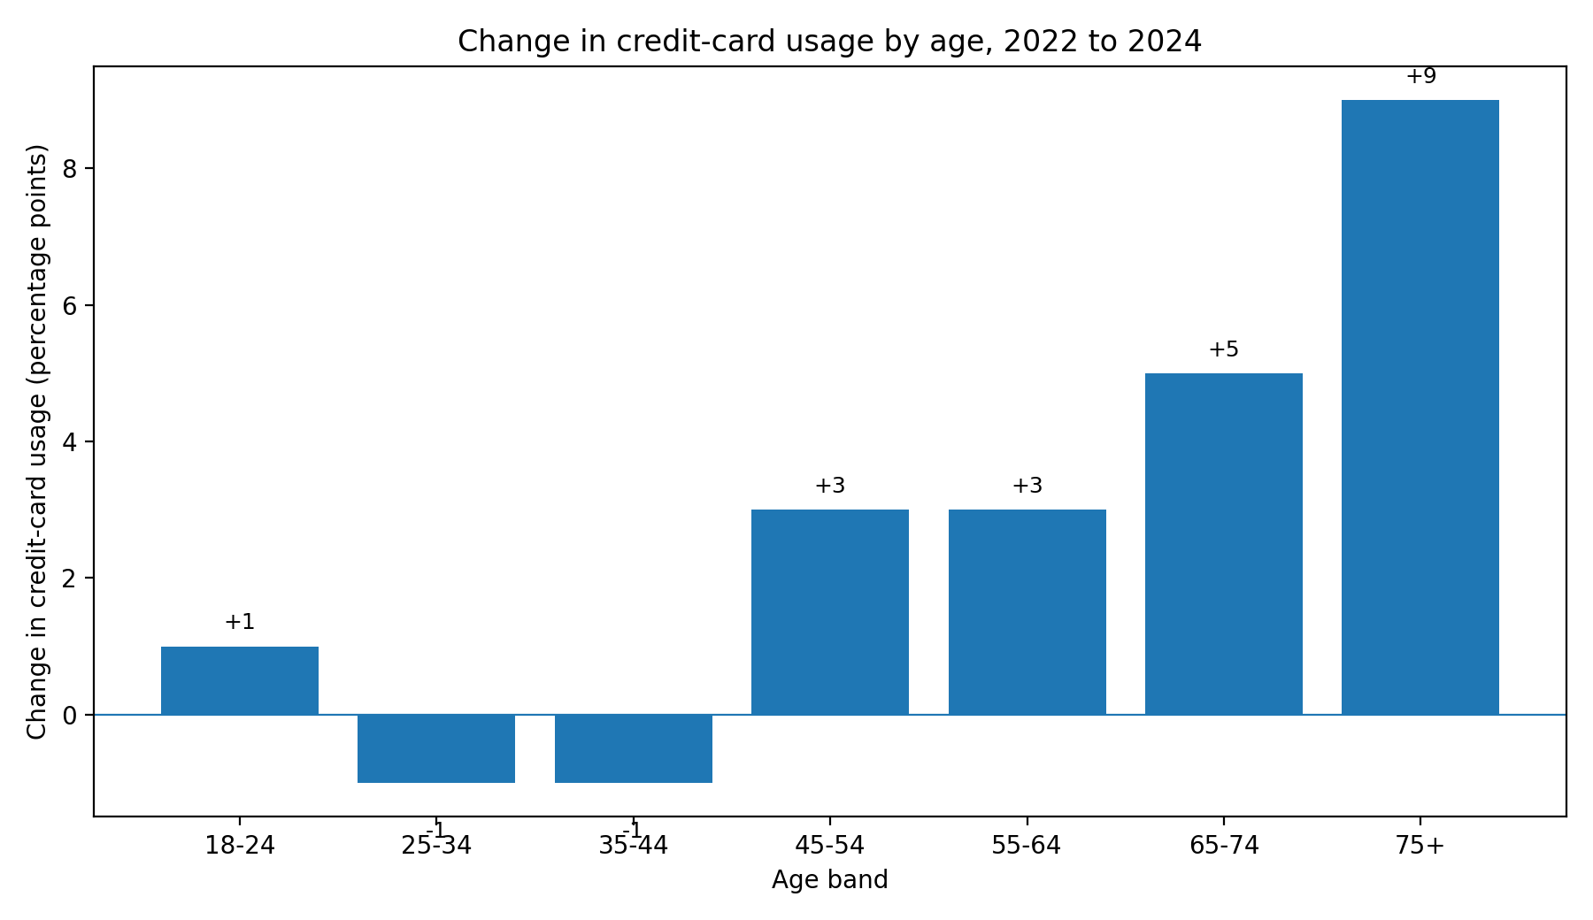
Figure 2. Percentage-point change in credit-card usage from 2022 to 2024 by age band. Source: Financial Conduct Authority (2025b).
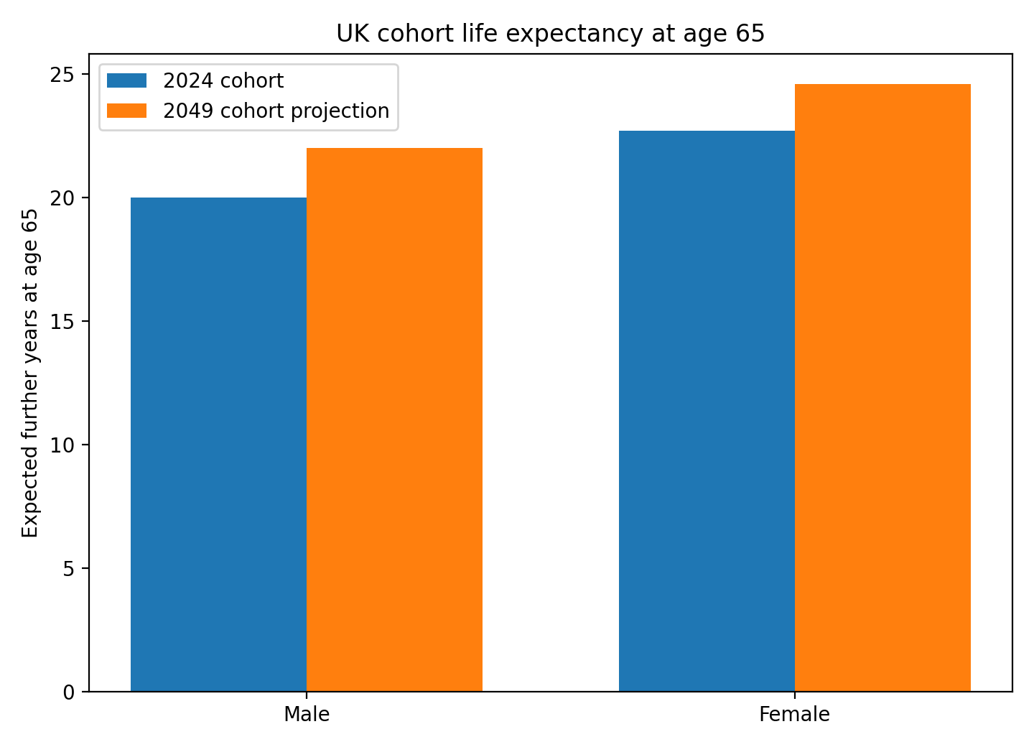
Figure 3. UK cohort life expectancy at age 65 for the 2024 cohort and 2049 projection. Source: Office for National Statistics (2026). Life expectancy is contextual and is not a measure of creditworthiness.
Part 2: Impact Evaluation
Evidence-Led Review of Credit Access for Older Credit-Card Customers

Executive Summary
This impact evaluation reviews an age-related credit-card process affecting older customers, particularly those around age 80 and above. It uses public FCA and ONS evidence to test whether chronological age remains a proportionate reason for additional manual processing, while retaining normal affordability, creditworthiness and vulnerability controls. FCA Financial Lives 2024 data shows that 74% of adults aged 75+ held a credit card and 67% had used one for goods or services in the previous year. The review therefore supports removing unnecessary age-only friction rather than weakening credit standards. Based on a student-supplied volume of around 2,000 affected customers each month and a 15-minute additional interaction, the current process represents about 500 staff hours monthly; using the 2026 National Living Wage only as a benchmark, the maximum wage-equivalent handling capacity is approximately £76,260 per year if all such interactions were avoided.
Project Background and Business Problem
The business problem is an additional manual process affecting some older credit-card customers when they apply for, or seek access to, credit-line functionality. The policy is intended to control risk, but chronological age can become a blunt trigger if it is used without checking whether the underlying customer risk has changed. The work therefore reviewed external evidence to ask a narrower question: does the available evidence justify reviewing an age-triggered manual process while keeping the normal credit assessment unchanged?
Around 2,000 customers per month are estimated to encounter the additional step, with an average interaction of about 15 minutes; these are business-context figures supplied for the evaluation rather than public statistics. The customer effect is additional time and friction before an application can be considered, and the operational effect is repeated servicing effort. The objective is not to approve all affected customers, nor to treat longevity as evidence of creditworthiness. The proposed change is to allow suitable older customers to proceed through the same evidence-led affordability and creditworthiness assessment as other customers unless a genuine risk or vulnerability reason requires additional support.
Approach, Data Infrastructure and Engineering
The external evidence layer was built from public, reproducible sources rather than internal customer records. The FCA Financial Lives 2024 survey is the main source because it is nationally representative and publishes both reports and underlying data tables. The analysis used age-banded credit-card ownership and usage, together with the FCA's broader measure of unsecured debt. ONS cohort life-expectancy statistics were used only as demographic context. Regulatory interpretation was checked against the FCA Consumer Duty and CONC 5.2A creditworthiness rules.
The engineering task was mainly one of definition and comparability. Age bands, survey years and measures were aligned before comparison, and values were kept in the categories actually published. The FCA's current public tables report a 75+ group, not a clean 80+ or 85+ credit-card segment, so the analysis does not invent an 80+ statistic by extrapolating from 75+; this is an important limitation given the workplace focus on very old customers. FCA unsecured-debt figures include revolving card balances alongside other unsecured borrowing, so they are useful context but not a direct measure of average credit-card balance for 80+ customers.
No confidential data is reproduced here. A production review would combine this external benchmark with governed internal age-band outcomes such as utilisation, arrears and losses, identified as a next-stage control rather than analysis already completed.
Analysis Performed
The clearest finding is that older adults remain an active credit-card population. In the FCA Financial Lives 2024 survey, 74% of adults aged 75+ held a credit card, compared with 78% of those aged 65-74 and 74% of those aged 55-64. The 75+ holding rate increased by nine percentage points between 2022 and 2024, the largest increase among the age groups shown. Usage is also high: 67% of adults aged 75+ used a credit card for goods or services in the previous 12 months, compared with 71% at ages 65-74 and 67% at ages 55-64 (Financial Conduct Authority, 2025a; 2025b). Figure 4 presents these two measures together.
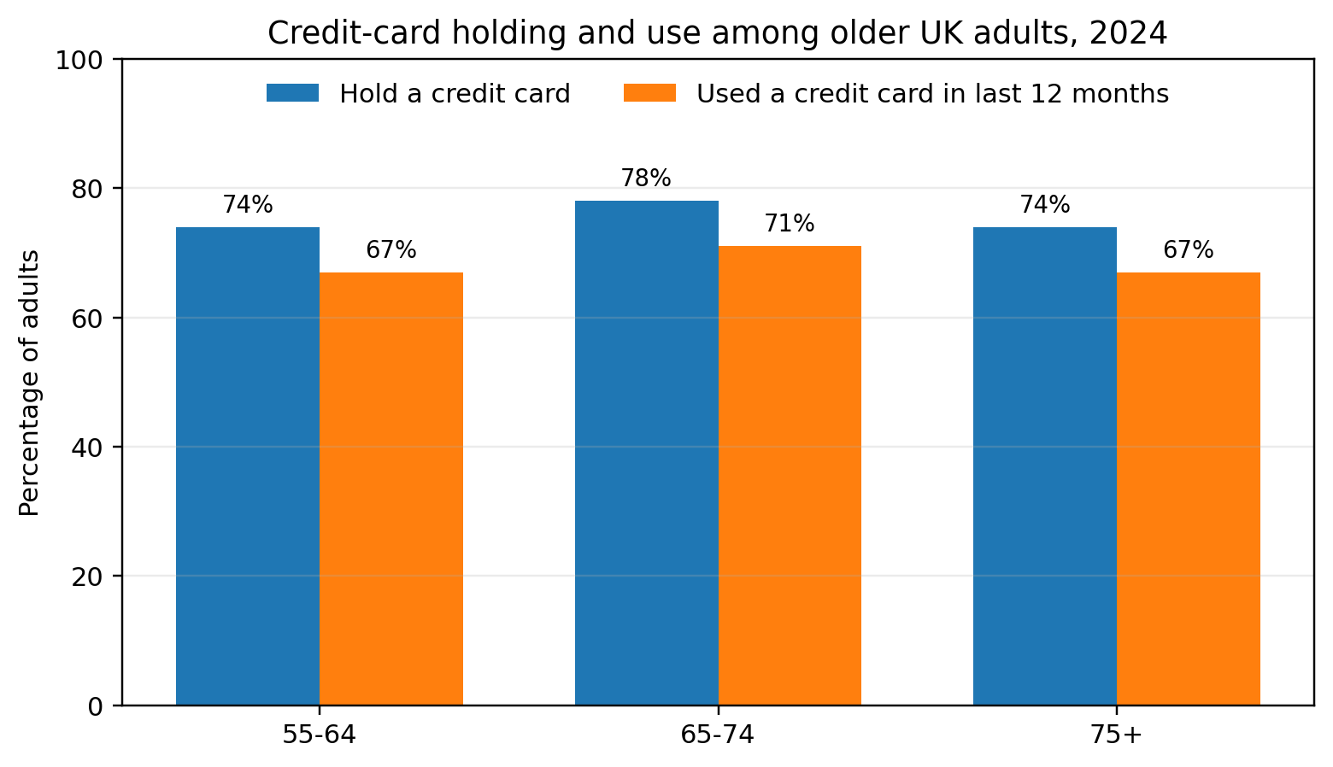
Figure 4. Credit-card holding and use among older UK adults, 2024. Source: Financial Conduct Authority (2025a; 2025b). Holding and usage are separate measures and neither is a direct measure of outstanding debt.
The broader debt picture does not show older consumers as the highest-debt group. FCA 2024 data reports that 16% of adults aged 75+ had unsecured debt excluding student loans, with a median of £0.4k among those with debt; for ages 65-74 the corresponding figures were 24% and £2.1k, well below the £3.8k median for the general adult population (Financial Conduct Authority, 2025c). This measure includes revolving card balances but is not card-specific, so it cannot infer an 80+ card balance.
Longevity is supportive context, not a lending variable. ONS cohort life tables estimate a further 22.7 years for a 65-year-old woman in 2024 and 20.0 years for a man, both projected to rise by about two years by 2049 (Office for National Statistics, 2026). This shows why policies designed around historic later-life assumptions should be reviewed periodically, but it does not show whether any individual can afford additional credit.
The combined evidence therefore supports a policy review, not automatic approval. The FCA Consumer Duty expects firms to monitor whether groups of customers receive worse outcomes and to address avoidable barriers. FCA implementation guidance also warns against automatically treating every consumer above a certain age as vulnerable. At the same time, CONC 5.2A requires a reasonable creditworthiness assessment based on sufficient and proportionate information. The practical implication is that removing an age-only manual step is defensible only if normal creditworthiness, affordability, fraud and vulnerability controls remain in place (Financial Conduct Authority, 2024a; 2024b; 2026).
Figure 4 separates card ownership from actual use so a high holding rate is not mistaken for borrowing. Figure 5 presents four operational scenarios rather than one headline saving, making the avoidance assumption visible. This gives decision-makers a clearer view of how value changes if only part of the manual activity is removed.
Results and Impact
The completed review produced an evidence-based case for testing a simpler journey for older customers rather than retaining an additional step solely because of age. Public data cannot prove that an individual customer aged 80+ is low risk, but it does challenge the assumption that very old age is associated with little credit-card participation. The high holding and usage rates among the 75+ population make it reasonable to test whether the existing process is producing avoidable friction.
For customers, the potential impact is access to a quicker, more consistent assessment: the approximately 2,000 customers affected each month would not automatically receive a higher limit, but would have the opportunity to move through the standard assessment where appropriate, while customers showing signs of vulnerability or affordability risk would still receive the additional support required.
For the business, the immediate impact is a quantified capacity opportunity. Two thousand 15-minute interactions equal 30,000 minutes, or 500 staff hours each month. Figure 5 shows the annual wage-equivalent capacity at different levels of interaction avoidance: a 50% reduction would release around 250 hours per month, full removal 500 hours. This capacity could be redirected to complex cases rather than assumed to be a direct cash saving.
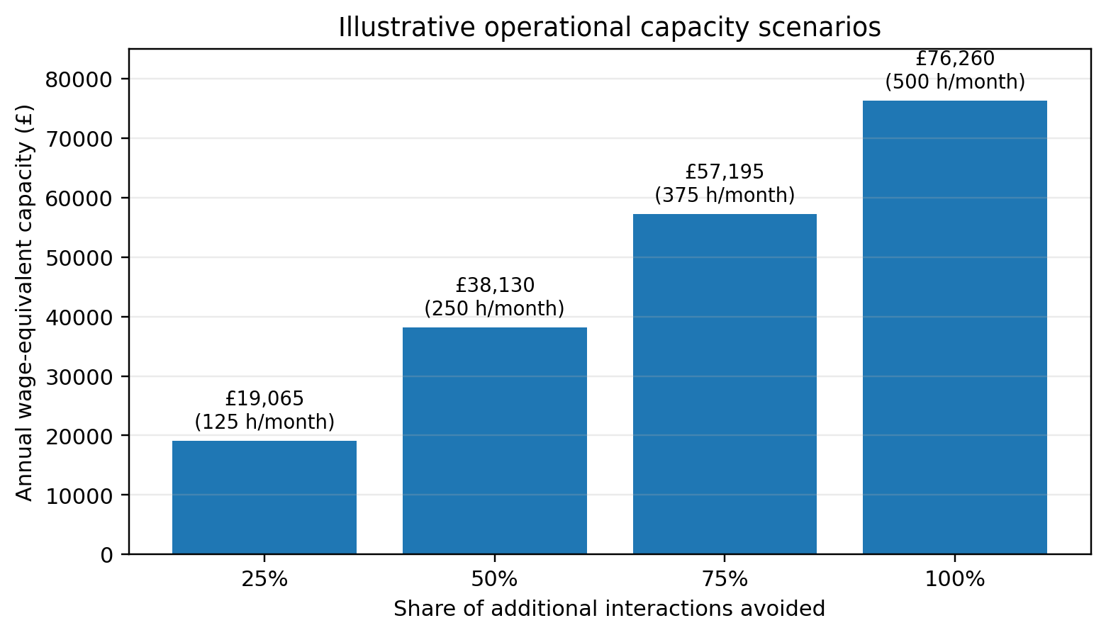
Figure 5. Illustrative annual wage-equivalent handling capacity at different levels of interaction avoidance. Source: student-supplied volumes and handling time; wage benchmark from GOV.UK (2026). This is capacity, not a guaranteed cash saving.
Value Estimate
The 2026 National Living Wage for workers aged 21+ is £12.71 per hour (GOV.UK, 2026), used here only as a transparent low wage-rate benchmark, not as the actual cost of a bank employee. At 25% interaction avoidance the wage-equivalent capacity is about £19,065 per year; at 50% it is £38,130; at 75% it is £57,195; and at 100% it is £76,260. This is an upper-bound benchmark because some interactions may remain necessary, released time does not automatically become a cash saving, and employer overheads are excluded.
There is also a possible revenue benefit if suitable customers obtain appropriate credit lines and subsequently use them, creating additional spend, interchange or interest income. No internal yield figure has been supplied, so no revenue value is claimed; a later evaluation could estimate this transparently as eligible customers multiplied by incremental utilised balance and annual yield, then compare the result with observed arrears and loss outcomes.
Recommendations and Reflection
The next step should be a controlled pilot rather than an immediate removal of all later-life checks. The pilot should compare older customers who enter the standard journey with a suitable benchmark and monitor approval rate, utilisation, repayment behaviour, arrears, complaints, vulnerability outcomes and servicing demand. This would test whether the external evidence translates into acceptable internal risk performance.
Age should remain available for outcome monitoring where lawful and necessary, but it should not be treated as a substitute for affordability or creditworthiness. Any redesigned process should preserve a route to additional support for customers whose circumstances indicate vulnerability, aligning with the Consumer Duty expectation to identify groups receiving poorer outcomes without assuming that every older customer is vulnerable.
The main limitation is the mismatch between the public 75+ age band and the workplace focus on roughly 80+; a second is that the quantified value is operational capacity, not an audited saving, and revenue uplift remains unmeasured. External evidence is therefore strong enough to justify testing the process, but a permanent policy change should depend on internal outcome monitoring after implementation.

References
Barocas, S., Hardt, M. and Narayanan, A. (2019) Fairness and Machine Learning. Cambridge, MA: MIT Press. Available at: https://fairmlbook.org (Accessed: 26 August 2026).
BPP University (2026) Data Science Professional Practice: Assessment Brief. London: BPP University.
European Union (2016) Regulation (EU) 2016/679 (General Data Protection Regulation). Official Journal of the European Union, L119, pp.1-88. Available at: https://eur-lex.europa.eu/eli/reg/2016/679/oj (Accessed: 26 August 2026).
Financial Conduct Authority (2017) Understanding the financial lives of UK adults: Findings from the FCA's Financial Lives Survey 2017. Available at: https://www.fca.org.uk/publication/research/financial-lives-survey-2017.pdf (Accessed: 26 August 2026).
Financial Conduct Authority (2022) Financial Lives 2022: Key findings from the FCA's Financial Lives May 2022 survey. Available at: https://www.fca.org.uk/publication/financial-lives/financial-lives-survey-2022-key-findings.pdf (Accessed: 26 August 2026).
Financial Conduct Authority (2024a) CONC 5.2A Creditworthiness assessment. FCA Handbook. Available at: https://handbook.fca.org.uk/handbook/conc5/conc5s6 (Accessed: 26 August 2026).
Financial Conduct Authority (2024b) Consumer Duty implementation: good practice and areas for improvement. Available at: https://www.fca.org.uk/publications/good-and-poor-practice/consumer-duty-implementation-good-practice-areas-improvement (Accessed: 26 August 2026).
Financial Conduct Authority (2025a) Financial Lives 2024 survey - Credit & loans: selected findings. Available at: https://www.fca.org.uk/publication/financial-lives/fls-2024-credit-loans.pdf (Accessed: 26 August 2026).
Financial Conduct Authority (2025b) Financial Lives 2024 survey - Payments: selected findings. Available at: https://www.fca.org.uk/publication/financial-lives/fls-2024-payments.pdf (Accessed: 26 August 2026).
Financial Conduct Authority (2025c) Financial Lives 2024: Key findings from the FCA's Financial Lives May 2024 survey. Available at: https://www.fca.org.uk/publication/financial-lives/financial-lives-survey-2024-key-findings.pdf (Accessed: 26 August 2026).
Financial Conduct Authority (2026) About the Consumer Duty. Available at: https://www.fca.org.uk/firms/consumer-duty/about (Accessed: 26 August 2026).
GOV.UK (2026) National Minimum Wage and National Living Wage rates. Available at: https://www.gov.uk/national-minimum-wage-rates (Accessed: 26 August 2026).
Government Digital Service (2020) The Government Data Quality Framework. London: GDS. Available at: https://www.gov.uk/government/publications/the-government-data-quality-framework (Accessed: 26 August 2026).
Great Britain (2010) Equality Act 2010, c.15. London: The Stationery Office. Available at: https://www.legislation.gov.uk/ukpga/2010/15/contents (Accessed: 26 August 2026).
Information Commissioner's Office (2026) A Guide to the Data Protection Principles. Wilmslow: ICO. Available at: https://ico.org.uk/for-organisations/uk-gdpr-guidance-and-resources/data-protection-principles/a-guide-to-the-data-protection-principles/ (Accessed: 26 August 2026).
Knaflic, C.N. (2015) Storytelling with Data: A Data Visualization Guide for Business Professionals. Hoboken, NJ: Wiley.
Office for National Statistics (2026) Past and projected period and cohort life tables: 2024-based, UK, 1981 to 2074. Available at: https://www.ons.gov.uk/peoplepopulationandcommunity/birthsdeathsandmarriages/lifeexpectancies/bulletins/pastandprojecteddatafromtheperiodandcohortlifetables/latest (Accessed: 26 August 2026).

